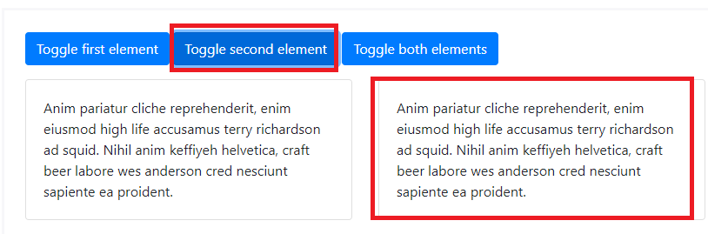

<p>

<a class="btn btn-primary" data-toggle="collapse" href="#multiCollapseExample1" role="button" aria-expanded="false" aria-controls="multiCollapseExample1">Toggle first element</a>

<button class="btn btn-primary" type="button" data-toggle="collapse" data-target="#multiCollapseExample2" aria-expanded="false" aria-controls="multiCollapseExample2">Toggle second element</button>

<button class="btn btn-primary" type="button" data-toggle="collapse" data-target=".multi-collapse" aria-expanded="false" aria-controls="multiCollapseExample1 multiCollapseExample2">Toggle both elements</button>

</p>

<div class="row">

<div class="col">

<div class="collapse multi-collapse" id="multiCollapseExample1">

<div class="card card-body">

Anim pariatur cliche reprehenderit, enim eiusmod high life accusamus terry richardson ad squid. Nihil anim keffiyeh helvetica, craft beer labore wes anderson cred nesciunt sapiente ea proident.

</div>

</div>

</div>

<div class="col">

<div class="collapse multi-collapse" id="multiCollapseExample2">

<div class="card card-body">

Anim pariatur cliche reprehenderit, enim eiusmod high life accusamus terry richardson ad squid. Nihil anim keffiyeh helvetica, craft beer labore wes anderson cred nesciunt sapiente ea proident.

</div>

</div>

</div>

</div>